|  |
| --- |
| QUY PHAM |
| Project 2 |
| A simple graph plotting console application |

|  |
| --- |
| CS 222  11/24/2008 |

**Project 2**

1. **Source code:**

// Project2.cpp : Defines the entry point for the console application.

//

#include "stdafx.h"

#include "math.h"

#include "conio.h"

#define X_SEMIRANGE 3

#define Y_SEMIRANGE 2

#define ROW (Y_SEMIRANGE*20 + 1)

#define COL (X_SEMIRANGE*20 + 1)

#define X_AXIS (Y_SEMIRANGE*10)

#define Y_AXIS (X_SEMIRANGE*10)

char graph[ROW][COL];

// function prototypes

double f(double x);

void init(void);

void printPlot(void);

void initAxis(void);

void initPlotPoints(void);

int _tmain(int argc, _TCHAR* argv[])

{

// initialize the graph[][] array

// - x and y axis

// - plotting points

init();

// mapping the graph[][] array to the screen

printPlot();

return 0;

}

double f(double x)

{

//return sin(3*x);

//return x*x;

//return cos(x*x);

return exp(-1/(x*x));

}

void init()

{

// mapping x and y axis into the graph[][] array

initAxis();

// mapping the plotting point into the graph[][] array

initPlotPoints();

}

void initAxis()

{

// loop through the graph[][] array

for(int i=0; i<ROW; i++)

for(int j=0; j<COL; j++)

{

// find the center indexes

// and mark them as x or y axis w/ char '-' and '|'

if(i == X_AXIS)

graph[i][j] = '-';

else if(j == Y_AXIS)

graph[i][j] = '|';

// elsewhere, put space ' ' instead

else

graph[i][j] = ' ';

}

}

// take input as double and then round it up

// then convert it to integer

int roundoff(double x)

{

int i;

if (x >= 0)

i = (int)(x + 0.5);

else /* i < 0 */

i = (int)(x - 0.5);

return i;

}

// take all values on x axis

// then plug in the f() function to get values on y axis

// convert those values (x or y coordinates) into array indexes

// and store char 'o' to the graph[][] array at those indexes

void initPlotPoints()

{

double yd;

int y;

for(int x=-Y_AXIS; x <= Y_AXIS; x++)

{

yd = f((double)x/10.0);

y = roundoff(yd*10);

y = X_AXIS - y;

if((y >= 0)&&(y <= ROW))

{

graph[y][x+Y_AXIS] = 'o';

}

}

}

void printPlot()

{

for(int i=0; i<ROW; i++)

{

for(int j=0; j<COL; j++)

{

printf("%c",graph[i][j]);

}

printf("\n");

}

}

1. **Output:**

f(x) = cos(x2), X_SEMIRANGE 3, Y_SEMIRANGE 2

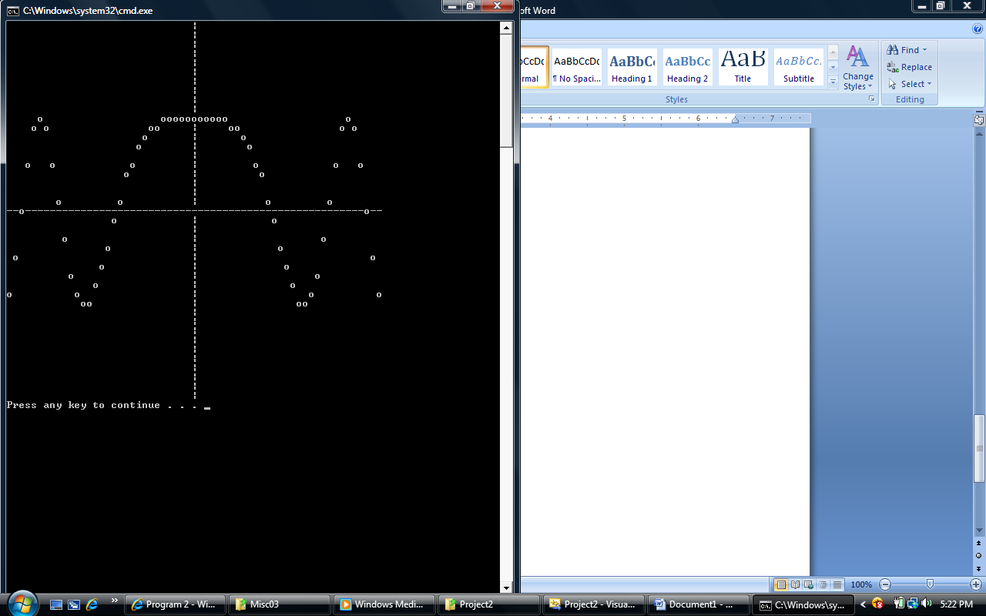

f(x) = exp(-1/x2), X_SEMIRANGE 3, Y_SEMIRANGE 1

